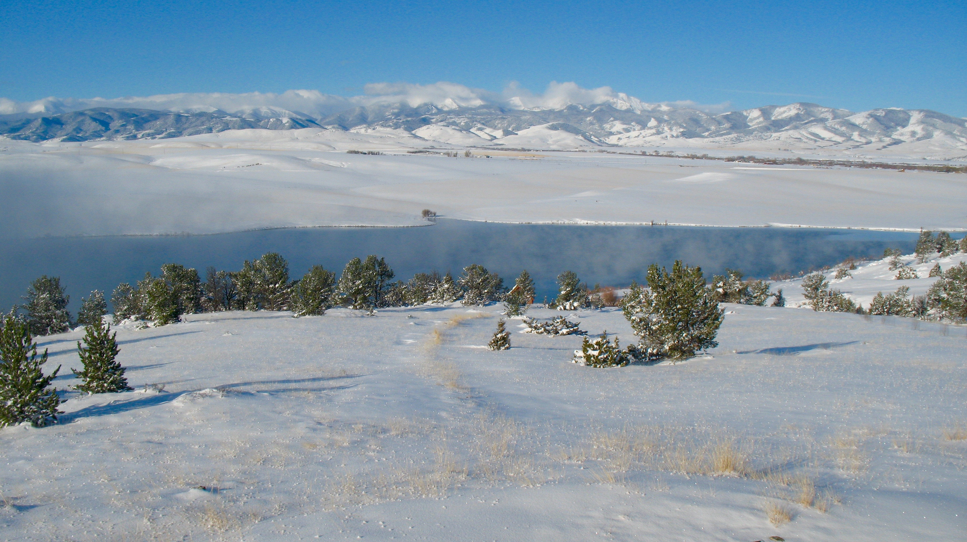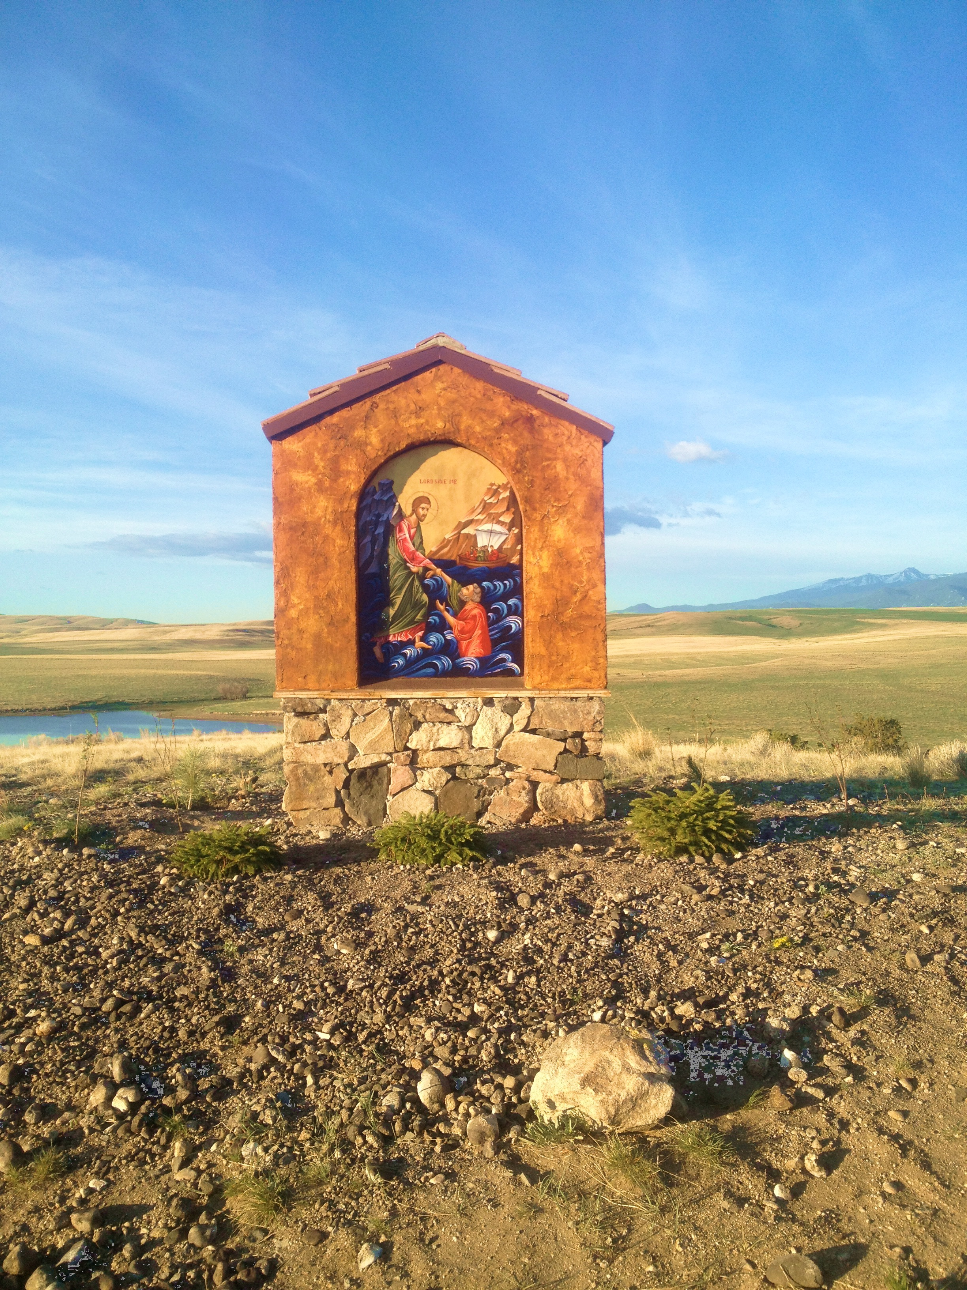

*“Angels are a light for monks, and the monastic life is a light for all*

*men.”*

--St. John Climacus, The Ladder of Divine Ascent

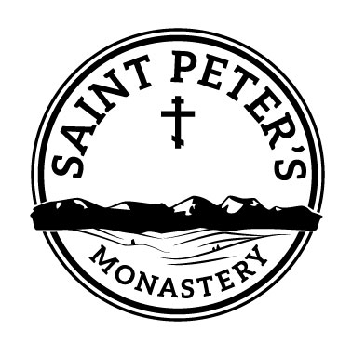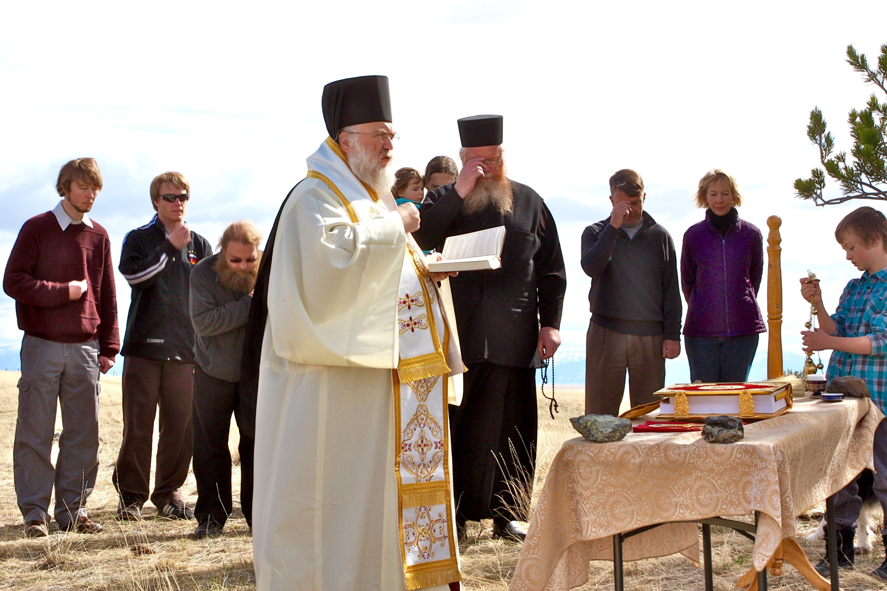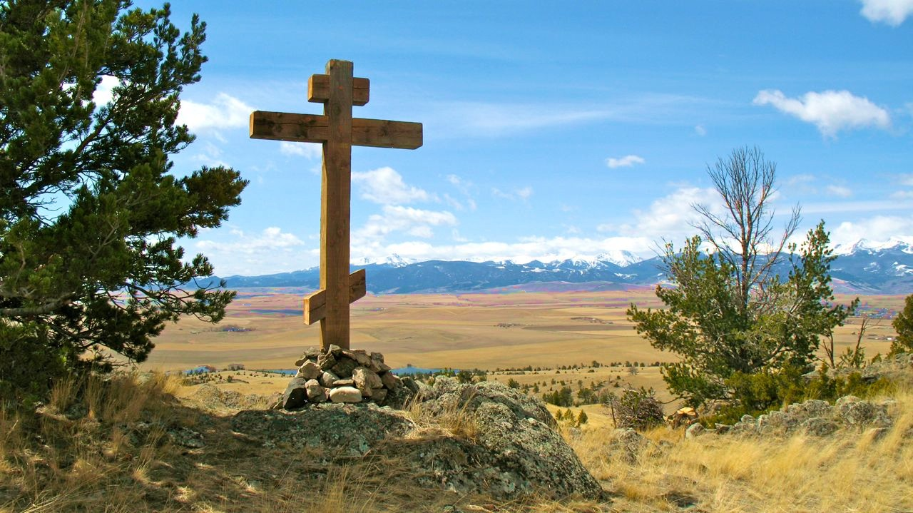

*"Rugged, pristine, sequestered beauty is what Montana can offer Monasticism.  Access to a spiritual life other than married, and a source for bishops for the Test Diocese of Montana is what Monasticism can offer Montana."*

--Fr. Russell Radoicich,

Holy Trinity Church,

Butte, Montana

*“The essential nature of monasticism is profound love for God and prayer for the world.  What a gift this will be for our land, and to our lives, as this vision for a monastic community comes to fruition in Montana—in God’s time, by God’s grace…and by our prayers and support.”*

—Fr. David Morrison, Rector,

St. Anthony Orthodox Church, Bozeman, Montana

**A VISION FOR MONTANA & THE MOUNTAIN WEST**

**StPetersMonastery.com**

David Hicks, Secretary

St. Peter's Monastery Foundation

P. O. Box 141

Harrison, Montana 59735

**StPetersMonastery.com**

[Postal Code]

[Web Address]

St Peter’s Monastery, established in 2014, is a tax-exempt 501(c)3 foundation recognized by the State of Montana. Archbishop Benjamin chairs its board. If you would like to learn more or wish to support this work, feel free to contact:

# Please pray with us that God will provide a way for *West of the Moon* ranch to become St. Peter's Monastery, a sequestered home for the prayer and worship of monastics and a source of spiritual strength and healing for faithful pilgrims and visitors.

On April 19, 2012 Archbishop Benjamin, attended by Abbot Meletios of St. John Monastery in Manton, California, conducted a moleban service, blessing the land designated for the future site of St. Peter’s Monastery. The owners of this beautiful thousand-acre ranch in Southwest Montana have pledged to place their land in a Church trust as soon as a monastery can be established on it.

*“An Orthodox monastery is the clearest representation of the Kingdom of God on earth that the Church can offer. The very person of a monk or a nun is a sign, in the Biblical sense, that Christ is indeed risen. The ‘other-worldly’ orientation of a monastic is a wordless witness to all who encounter him that this is not all there is. ‘For the form of this world is passing away.’ (I Cor. 7:31). Saint Peter's will be the first Orthodox monastery in the State of Montana. Our brotherhood is honored to be involved in this ground-breaking, Kingdom-advancing work.”*

--Hieromonk Innocent, Abbot

St. John Monastery

Manton, California

St. Peter’s Monastery is ideally situated to offer a sequestered life for monastics, as well as to support the growth of the Church in Montana and throughout the Mountain West. Surrounded by mountains in sparsely-populated ranchlands, it lies off the grid, generating its own electricity from wind and sun, and forms the north shore of an undeveloped lake roughly six miles long. Yet it is also located in the center of the State, only an hour’s drive from the Bozeman and Butte airports.